Robert Minson

January 26, 2023

SYM-408

Prof. Dilts

No SQL

List of three hotels all with names, addresses, rates for the room offered and room types offered.

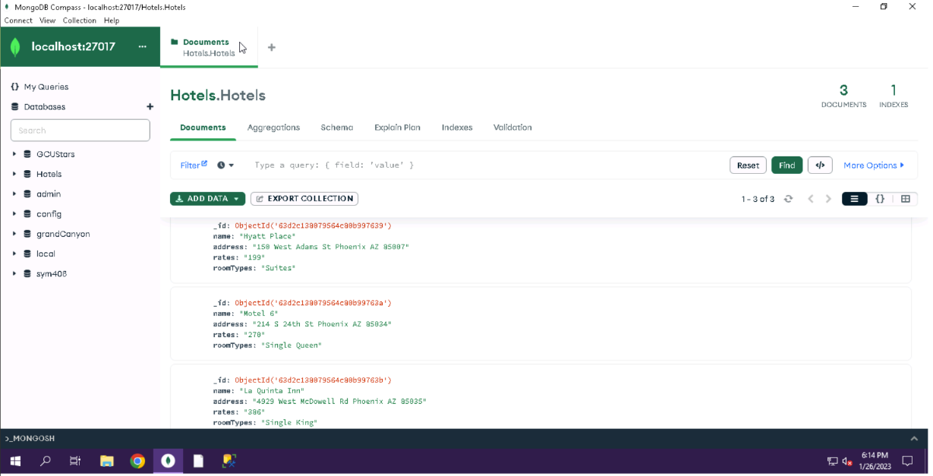

List of three hotels all with names, addresses, rates for the room offered and room types offered. With three different amenities included for each hotel.

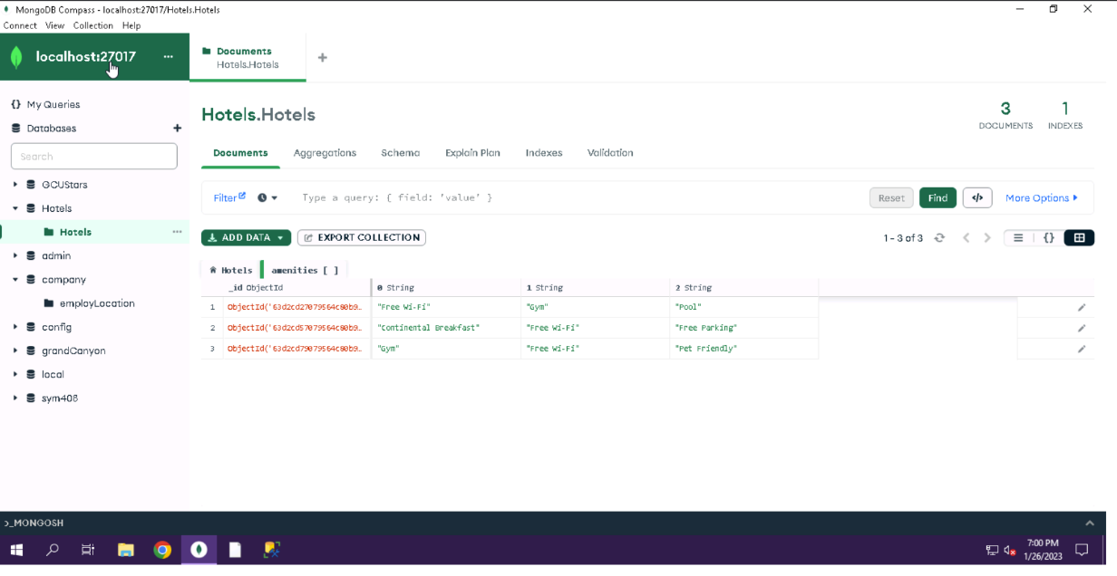

List of three hotels all with names, addresses, rates for the room offered and room types offered. With three different amenities included for two of the hotels.

